

**Home About Us Day/Residential Services Contact Us Careers**

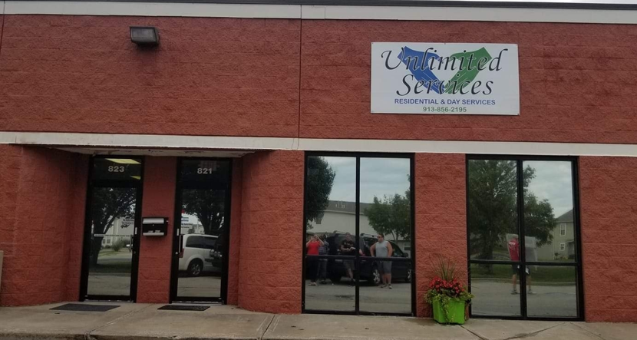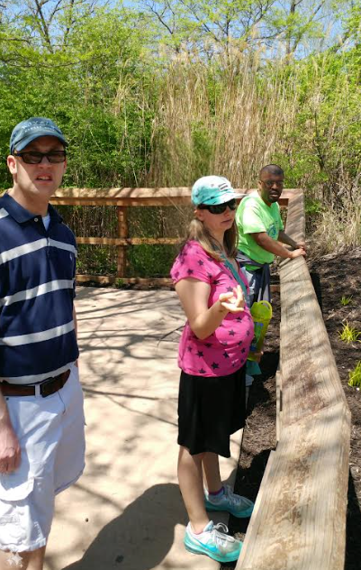*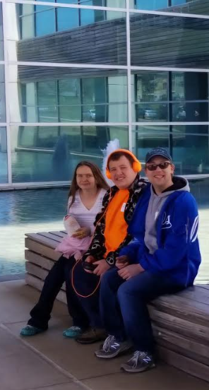 Welcome to Unlimited Services*

Providing

**30**Years of Service

Unlimited Services provides both Residential and Day Program Services to support individuals living with intellectual and developmental disabilities through Home and Community Based Services. Since our founding in 2012, we’ve developed the expertise and experience to care for individuals who may have more challenging support needs.

Unlimited Services strives to create a warm and inviting care facilities that resonates with clients and their families.

***We're Family, Not Just Care***

**Contact Location**

Office Hours: Mon-Fri (7:30am-3:30pm)821 E Lincoln Lane

(913) 856-2195 Gardner, KS, 66030

**Home About Us Day /Residential Services Contact Us Careers**

*About Us*

*Unlimited Services has provided special needs adults with home community-based services and support for the past 30 years.*

**Mission:** Empower and improve the well-being of people who experience barriers to independence.

**Vision:** Is to provide the best quality services for individuals living with a disability ensuring their lives are meaningful, productive, and normal.

**Unlimited Services’ Goals for our Direct Support Professionals are to develop PRIDE:**

**P**ursuing excellent service

**R**espect for individuals

**I**ntegrity for the community

**D**edicated to our Mission

**E**mpowerment to others

**Contact Location**

Office Hours: Mon-Fri (7:30am-3:30pm)821 E Lincoln Lane

(913) 856-2195 Gardner, KS, 66030

**Home About Us Day/Residential Services Contact Us Careers**

*Day/Residential Services*

# *Unlimited Services offers Day and Residential Services.*

# Day Services:

# Day Service is designed to help clients enhance their personal, social, vocational skills to live successfully in the community. Clients that participate in this program will follow an individual plan. Day Service hours are 9am-2pm Monday through Friday.

# A group of people walking in front of a barn Description automatically generatedActivities at our Day Program include:

# Community Access

# Volunteering

# Exercise

# Group sports

# Activities for day to day living skills

# Arts and Crafts

# A couple of men wearing hats and a hat and a scarf Description automatically generatedComputer

# Music Therapy

# Cooking, shopping for meals

# Individualized shopping

# Cookouts, lunch outings and many more community activities

# Residential Services:

# Our clients can expect a homelike atmosphere and Unlimited Services staff will be respectful and caring of the client’s rights. The client can expect their new home will be just that “their home.” Staff will provide the necessary support to teach our clients how to be as independent as possible.

**Contact Location**

Office Hours: Mon-Fri (7:30am-3:30pm)821 E Lincoln Lane

(913) 856-2195 Gardner, KS, 66030

**Home About Us Day /Residential Services Contact Us Careers**

*Contact Us*

*If you have general inquiries or would like a tour of our facilities, please complete the contact form or reach out to us at the e-mail or phone number below!*

[*Unlimitedservices9112@gmail.com*](mailto:Unlimitedservices9112@gmail.com) *(913) 856-2195*

**Contact Location**

Office Hours: Mon-Fri (7:30am-3:30pm)821 E Lincoln Lane

(913) 856-2195 Gardner, KS, 66030

**Home About Us Day /Residential Services Contact Us Careers**

*Careers*

*Unlimited Services believes in a team approach. We seek compassionate and reliable employees who are driven to provide the best care for our clients.*

***Position:******Direct Support Professional***(DSP) is an opportunity to make meaningful contributions to the daily lives of others. As a DSP, you will work with individuals with intellectual and developmental disabilities, guiding them to lead fulfilling and independent lives.

Valid Driver’s License and background checks required.

Please click on the link below to complete an application and consent for background checks.  The application will be electronically submitted to Unlimited Services, and our Admin will follow up with eligible applicants to schedule an interview.  Thank You!

**Online Employment Application**

**Apply Here**

**Contact Location**

Office Hours: Mon-Fri (7:30am-3:30pm)821 E Lincoln Lane

(913) 856-2195 Gardner, KS, 66030

*Employment Application Format*

